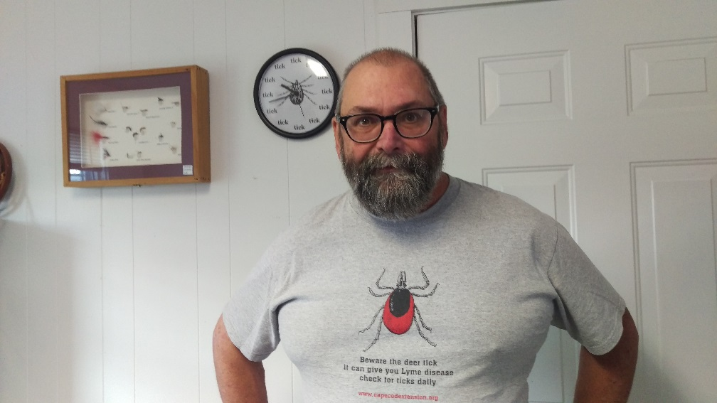

Larry Dapsis
Entomologist – Cape Cod Cooperative Extension

Ticks: “One Bite Can Change Your Life…”

Lyme Disease is the most prevalent tick-borne disease in Massachusetts and is now considered to be a public health crisis. In addition to Lyme, deer ticks can carry the pathogens which cause Babesiosis, Anaplasmosis, Relapsing Fever and Powassan virus, all of which can be very serious.

This program will review the basic life cycle and ecology of deer, dog and lone star ticks. This will include an exercise in tick identification using temporary tattoos. A handout for parents will be provided that covers all elements of personal protection.

Pollination Ecology – How Can We Help Bees?

Honeybees, both locally and nationally have been suffering catastrophic losses. This program will review honey bee biology and the factors responsible for this problem. In addition, we will review the state of wild pollinators like bumble bees and the things residents can do to help them. Many of the fruits and vegetables we eat require pollination. The current situation with murder hornet in the US will be discussed.

Insect Evolution

Insects are the most numerous and diverse group of animals on the planet representing over 25% of all forms of life on the planet. A series of examples will be showcased to show structural adaptions for protection including changes triggered by manmade events like pollution. There are evolutionary adaptations in behavior to enhance protection from natural enemies and to enhance predation ability…fireflies present a stunning example here.

Edible Insects, an Introduction to Entomophagy!

Insects are part of many diets around the world with the exception of North America and Europe. There are a number of valid reasons to consider rethinking our attitude about insect-based foods including sustainability and nutrition. Don’t be faint of heart for this exciting tour of culinary treats.

The Backyard Garden: It’s a jungle out there

Insect pests of small fruits and vegetables. Identification, life cycles, damage and management strategies including beneficial insects.

The Good…The Bad and the Bugly

The world of full of insects. Some we consider to be nuisances or pests. Others are insects that keep pests under control. There’s a lot of innocuous insects that are unique and very cool. Welcome to a tour of the insect world.

Forensic Entomology: Who dunnit?

Insects are now used to investigate a number of problems ranging from contamination of foods, apartment problems to violent crimes including murder. Learn about the key bug players and how they have helped to solve crimes that conventional investigation techniques could not.

Bio for Larry Dapsis – Entomologist since age 5. B.S. Environmental Science & Biology at Fitchburg State University and M.S. Entomology at the University of Massachusetts – Amherst. Forty years of professional pest management experience including Vegetables, Cranberries and Household Insects. Joined Cape Cod Cooperative Extension in 2011 as Deer Tick Project Coordinator and Entomologist and is a member of the Barnstable County Tick-Borne Disease Working Group.

